 | TOWN OF HOPEDALE  PLANNING BOARD  78 Hopedale Street - P.O. Box 7  Hopedale, Massachusetts 01747  Tel: 508-634-2203 X305 Fax: 508-634-2200

TOWN OF HOPEDALE PLANNING BOARD

Hopedale, Massachusetts 01747

Notice of Public Hearings

Notice is hereby given that the Hopedale Planning Board will conduct a public hearing on Wednesday, July 6, 2016 in the Draper Room, Hopedale Town Hall at 78 Hopedale Street, Hopedale, MA on the following application.

7:00PM

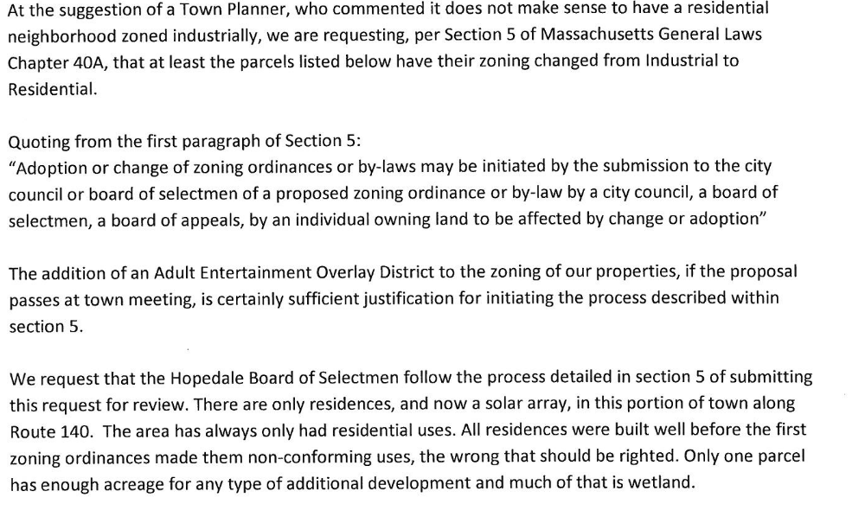

All interested parties may be present at the appointed time.

_________________________
Brian Keyes, Chairman

